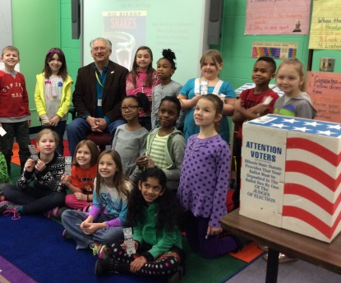

Mayor Broda with students from Miss Mik’s second grade class

On February 20th Lisle’s Mayor Broda served as the election judge for the annual Tate Woods Monarch Award voting. Every first and second grade student voted from a list of twenty nominated titles. This Children’s Book Choice award for the State of Illinois is sponsored by the Illinois School Library Media Association to encourage reading in grades K through Three.

Reading for the Monarch Award began on the first day of the 2014-15 school year with Principal Wesley Gosselink sharing Creepy Carrots by Aaron Reynolds and illustrated by Peter Brown at an assembly. Aaron Reynolds came to Tate Woods in October for student daytime presentations and family reading night. Reynolds shared his thought process as an author and autographed books for the students. Classroom teachers continued reading the nominated Monarch titles; making connections to genres, themes, social/emotional learning, and the Common Core.

The top vote getter at Tate Woods School was The Day the Crayons Quit by Drew Daywalt and illustrated by Oliver Jeffers. Creepy Carrots came in second place. That Is Not a Good Idea! by Mo Willems rounded out the voting in third place. 19 of 20 nominated titles received at least one vote!

The official state winner of the Monarch Award will be announced on March 20th during a live webcast assembly. Check out the 2016 Monarch list on the website!

The preschool classes chose My Bus by Byron Barton as their favorite from the Tate Woods Nan Reeves Caterpillar Award list.

